Date: Click or tap here to enter text.

To Whom It May Concern:

This letter is to verify that Click or tap here to enter text. has been offered the following on-campus employment at SUNY Jamestown Community College

Position: Click or tap here to enter text.

Brief Description of Duties: Click or tap here to enter text.

Start Date: Click or tap here to enter text. Hours Per Week: Click or tap here to enter text.

Employment Identification Number (EIN): Click or tap here to enter text.

Supervisor Name Click or tap here to enter text.
Supervisor’s Phone Number: Click or tap here to enter text.

Supervisor Signature:

If you have any questions, please do not hesitate to contact me.
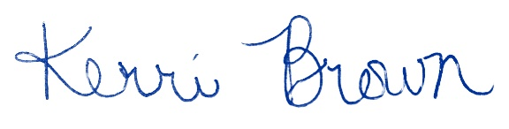
Kerri Brown | She, Her, Hers
Director of Global Learning, Primary Designated School Official
PH: +1 716-338-1291
sunyjcc.edu
Jamestown Community College
525 Falconer Street | P.O. Box 20 | Jamestown, NY 14702-0020

